Monitor de vía
User manual

 | Author | Date
Creation | DVERA | 26/05/2025
Last Revision | DVERA | 22/09/2026

DOCUMENT REVISIONS

Revision | Date | Author | Pages | Modifications
1 | 26/05/2025 | DVERA | All | Initial version. Dashboard images.
2 | 22/09/2026 | DVERA | All | Document translated to English. Added the DLG_InicioCobroActual screen, which now shows the pending amount to pay.

Content
1. General description 4
2. Screens/Events 4
3. Examples 5
- Car park with physical ticket. Entry terminal 5
- Ticketless car park. Entry terminal 7
- Car park with/without ticket. Exit terminal 10

General description
This document presents example screens for the different installation cases of the Monitor de vía: entry or exit terminal, and car parks with a physical ticket or ticketless car parks.

Screens/Events
The application shows a screen for each event sent by the parking terminal. The events depend on whether the terminal is an entry or an exit terminal, and each event has a specific code:

 | Code | Name | Description
1 | 5 | IDLE | Terminal idle
2 | 9 | READING_PLATE | Reading licence plate
3 | 12 | PLEASE_PROCEED | Licence plate read, access authorised
4 | 8 | USER | Licence plate could not be read; follow the instructions on the terminal screen
5 | 6 | DLG_OUT_SERVICE | Terminal out of service
6 | 1005 | IDLE_DISCONNECTED | Monitor lost the connection with the terminal
7 | 18 | DLG_CARD_ERROR | Validation error; contact the staff through the intercom
8 | 96 | DLG_BLOCKED | Terminal locked
9 | 7 | DLG_PARKING_FULL | Car park full (entry only)
10 | 36 | DLG_PAYMENT_REQUIRED | Payment pending (exit only)
11 | 89 | DLG_InicioCobroActual | Automatic payment in progress. The screen shows the pending amount to pay (exit only, usually with Via-T)
12 | 0 | DLG_BOOT | Terminal rebooting

Examples

Car park with physical ticket. Entry terminal
Terminal idle | Reading licence plate | Waiting for user action
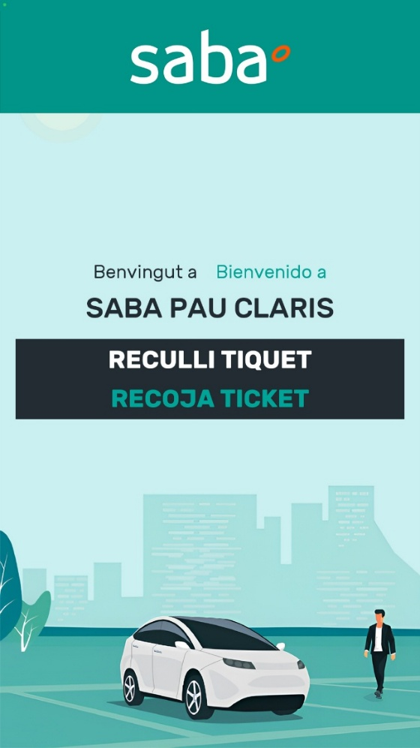 | 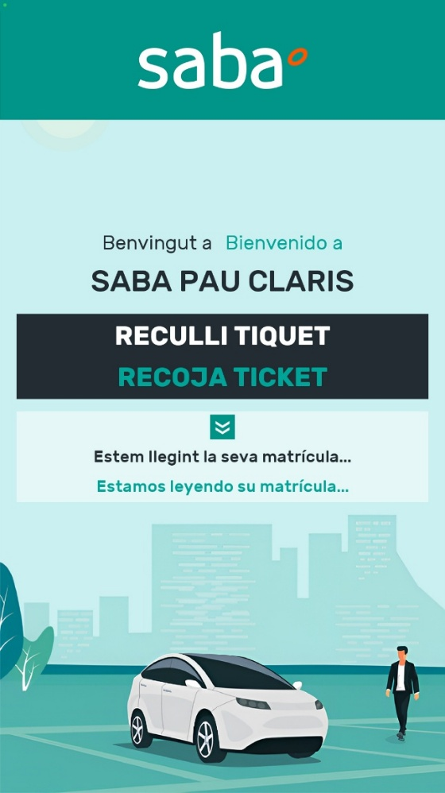 | 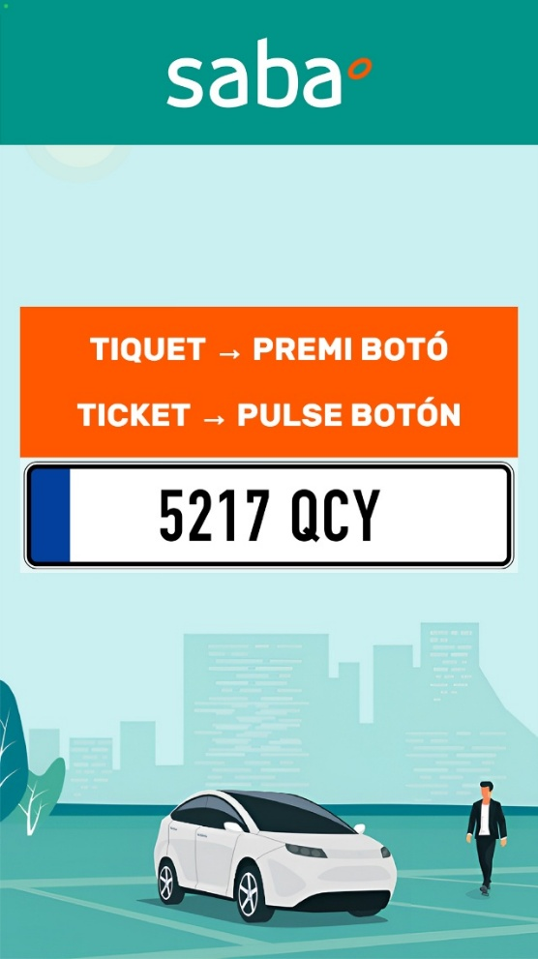

Subscriber entry. If the entry is made with Via-T, the Via-T pictogram is shown | Rotation ticket entry with Via-T. If the entry is made without Via-T, the Via-T pictogram is not shown | Car park full
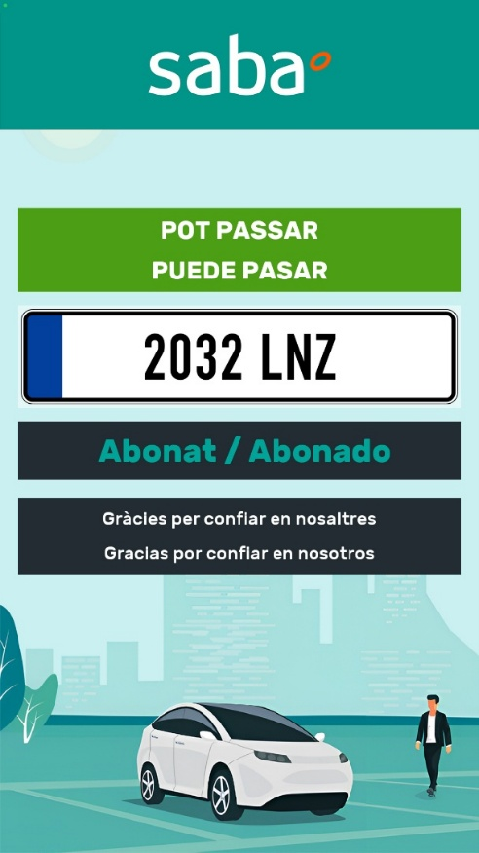 | 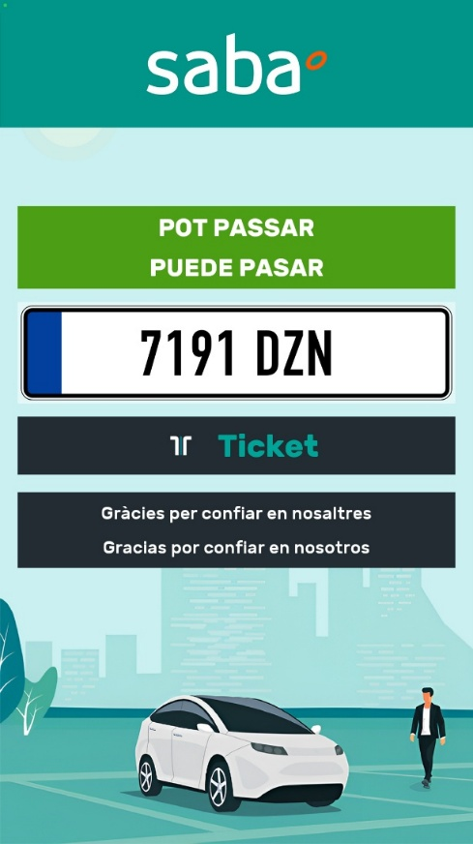 | 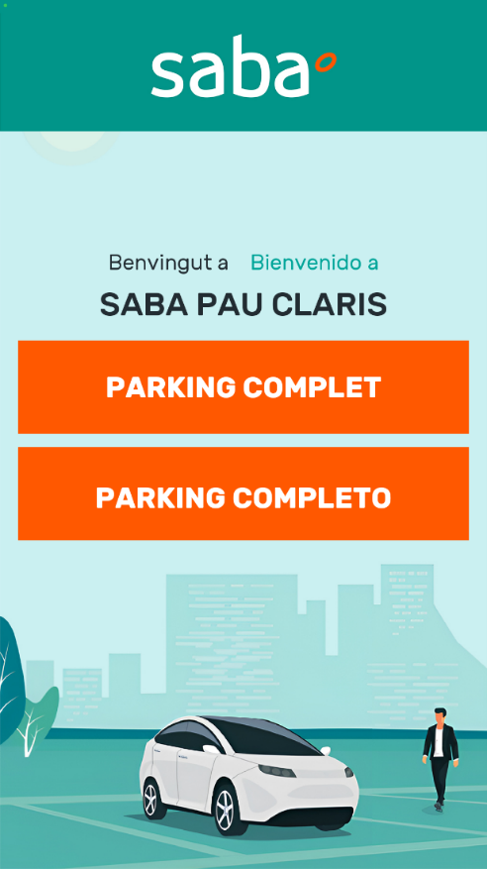
Terminal out of service, locked or rebooting | Car park access error | Monitor de vía without connection to the terminal
 | 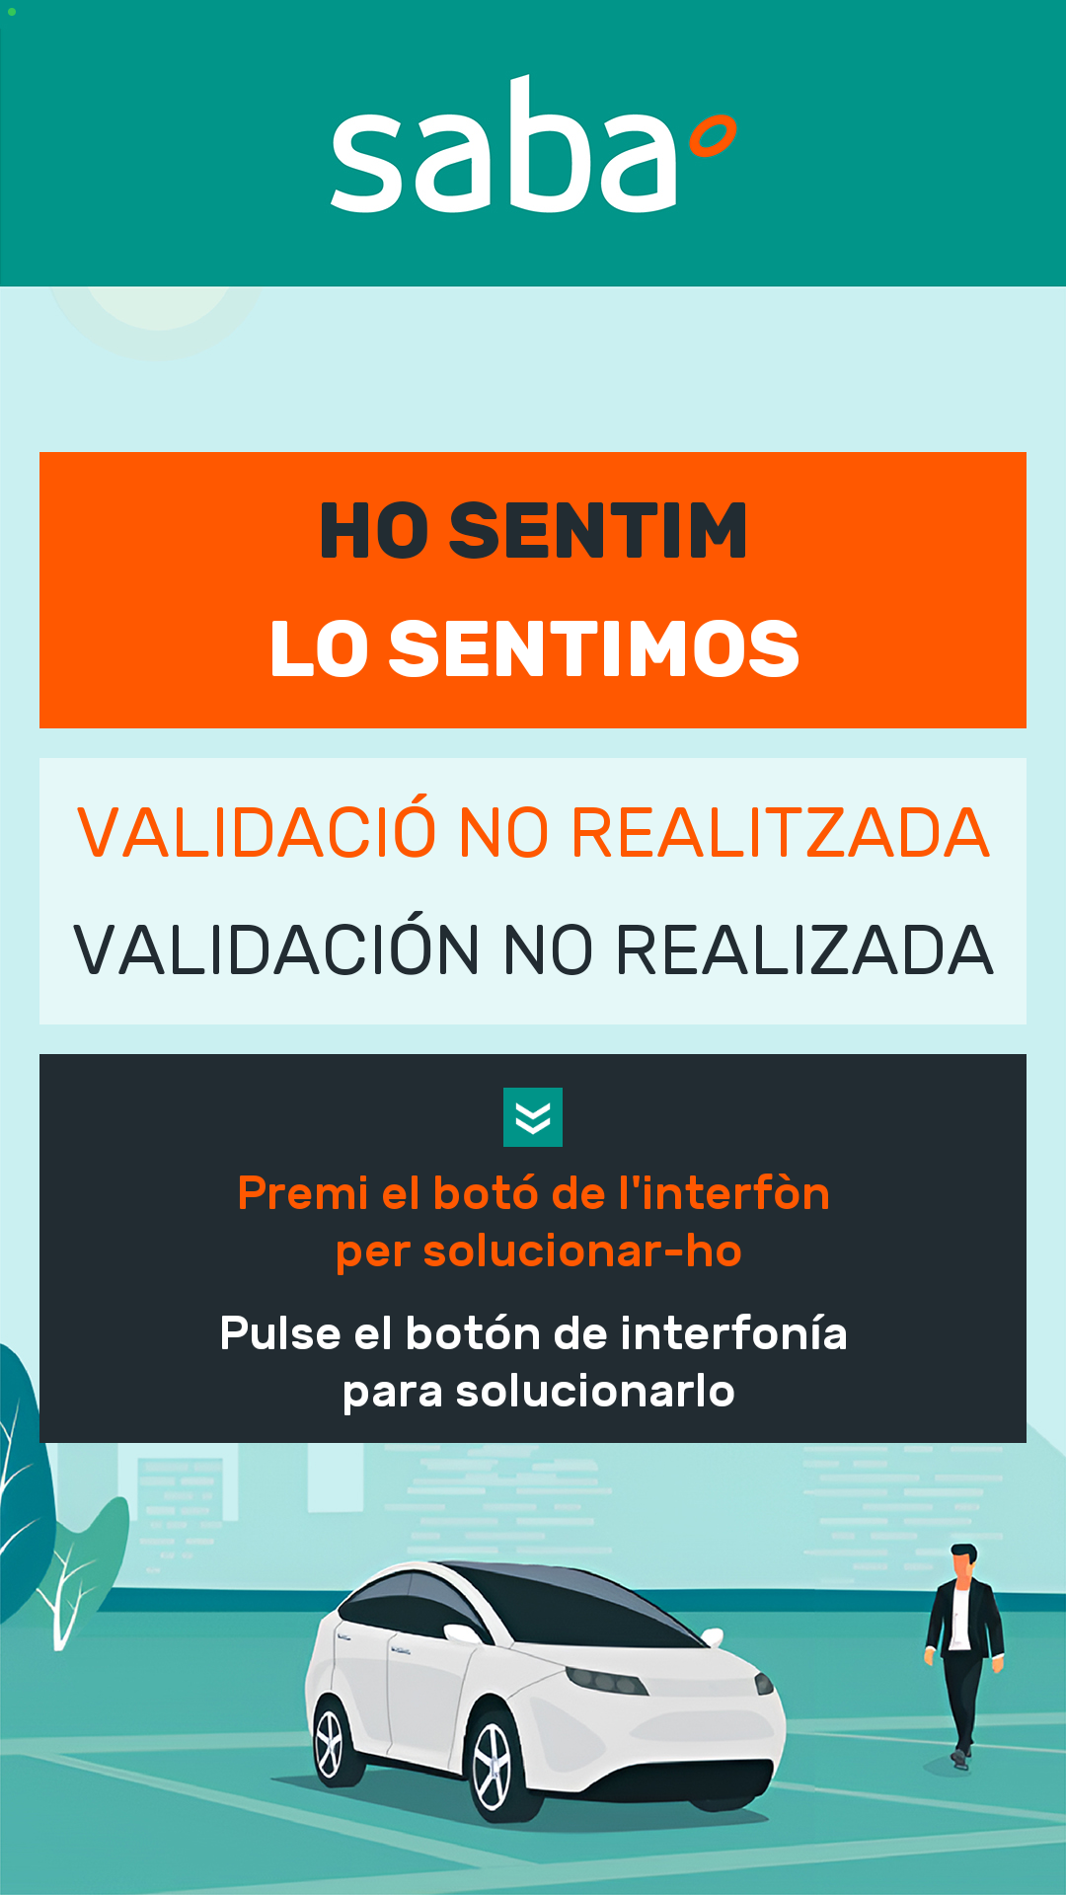 | 

Ticketless car park. Entry terminal
Terminal idle | Reading licence plate | Waiting for user action
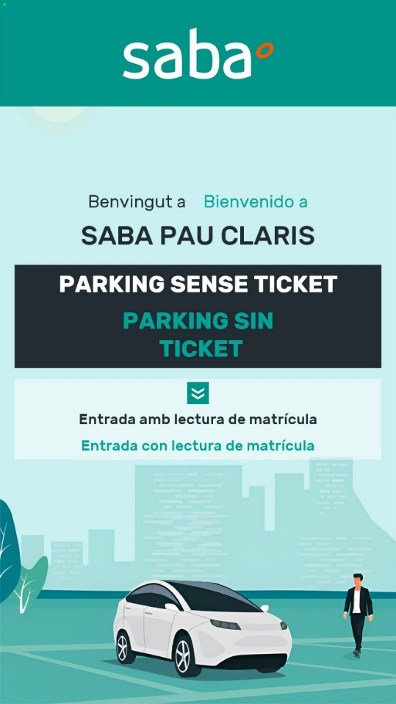 | 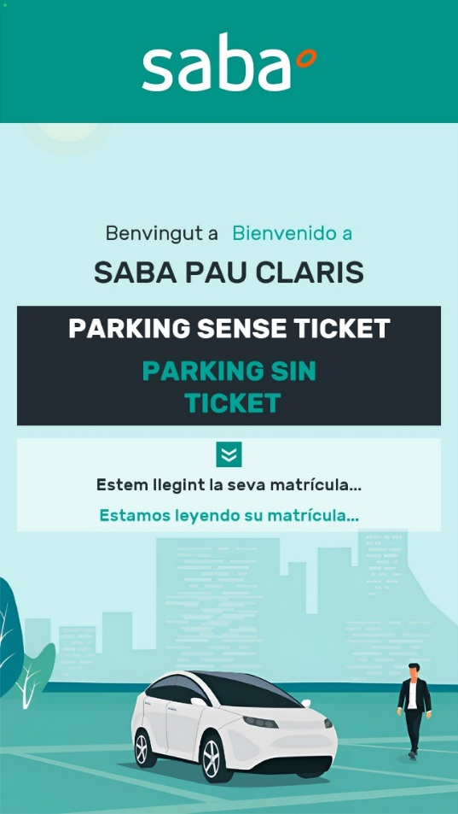 | 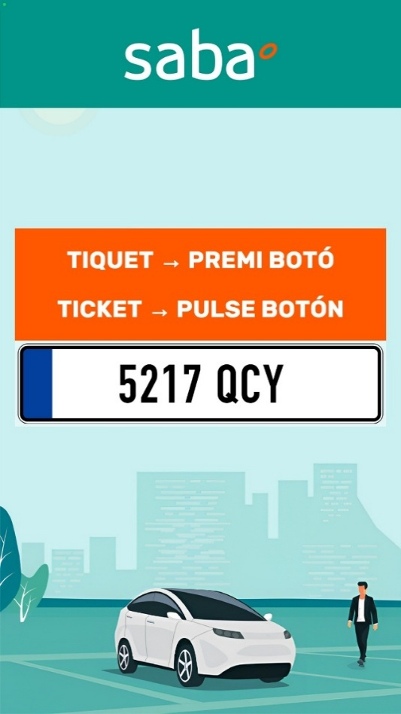
Subscriber entry. If the entry is made with Via-T, the Via-T pictogram is shown | Rotation ticket entry with Via-T. If the entry is made without Via-T, the Via-T pictogram is not shown | Car park full
Terminal out of service, locked or rebooting | Car park access error | Monitor de vía without connection to the terminal

Car park with/without ticket. Exit terminal
Terminal idle | Reading licence plate | Waiting for user action
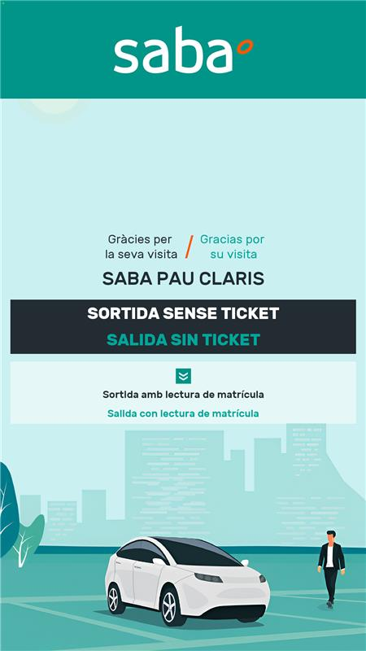 |  | 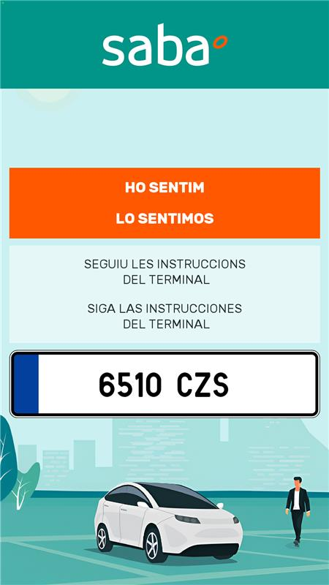
Subscriber exit. | Ticket exit. | Amount pending payment
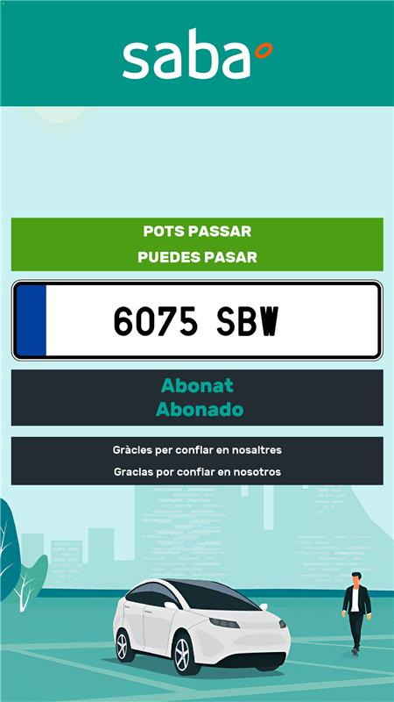 |  | 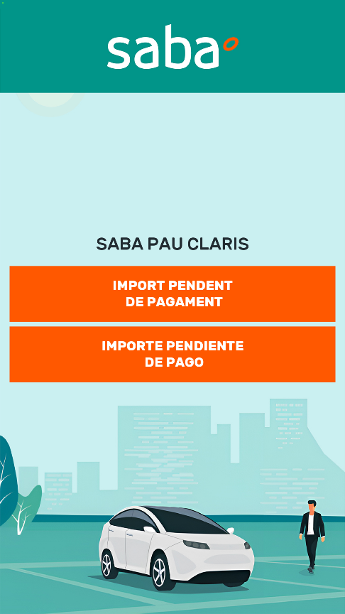
Terminal out of service, locked or rebooting | Car park access error | Monitor de vía without connection to the terminal
 |  | 
Processing payment. Shows the pending amount to pay (DLG_InicioCobroActual).
